EASTVIEW | HIGH | SCHOOL
6200 - 140th Street West, Apple Valley, Minnesota 55124 Email: eastview@district196.org Web: www.district196.org/evhs Phone: 952-431-8900

est. 1997

2019-2020 Calendar
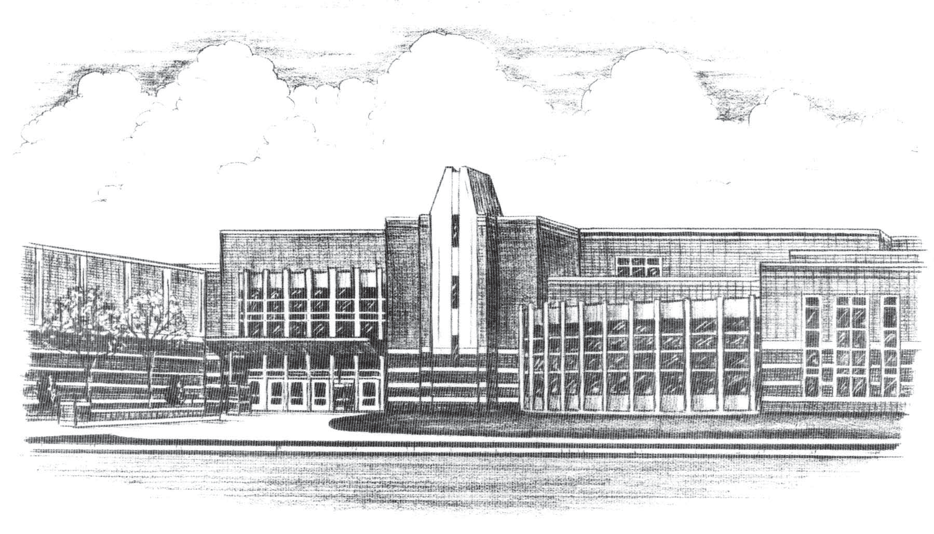

AUGUST |  |  |  |  |  | 2019
SUNDAY | MONDAY | TUESDAY | WEDNESDAY | THURSDAY | FRIDAY | SATURDAY
 |  |  |  | 1 | 2 | 3
 |  |  |  | Parking Permit On-line Applications available
4 | 5 | 6 | 7 | 8 | 9 | 10
11 | 12 | 13 | 14 | 15 | 16 | 17
• Opening Day:
- Cross Country - Boys’ & Girls’
- Football
- Soccer - Boys’ & Girls’
- Swimming & Diving - Girls’
- Tennis - Girls’
- Volleyball
18 | 19 | 20 | 21 | 22 | 23 | 24
25 | 26 | 27 | 28 | 29 | 30 | 31
 |  |  | • Parking Permit pick-up,  11:00 a.m. – 1:00 p.m.  • Freshmen and New Student  Orientation, 6:30 p.m. | • Parking Permit pick-up,  11:00 a.m. - 1:00 p.m.
For up-to-the-date calendar information, go to: www.district196.org/evhs then “click” Activity Calendar

SEPTEMBER |  |  |  |  |  | 2019
SUNDAY | MONDAY | TUESDAY | WEDNESDAY | THURSDAY | FRIDAY | SATURDAY
1 | 2 | 3 | 4 | 5 | 6 | 7
 | Labor Day  • No School | • First Day of School  • Pepfest
8 | 9 | 10 | 11 | 12 | 13 | 14
 | • School Picture Day  • Parent Open House,  6:30 p.m. |  |  |  |  | • ACT Test
15 | 16 | 17 | 18 | 19 | 20 | 21
.Q4 Spring ‘19 Incomplete
Deadline

22 | 23 | 24 | 25 | 26 | 27 | 28
 | • Homecoming Week  •• Q1 Pass/No Credit  Deadline | • Homecoming Week | • Homecoming Week | • Pepfest  • Homecoming Week | • No School – HS Data Analysis
29 | 30
• Q1 Progress Reports
Communication
• Picture Retake Day
For up-to-the-date calendar information, go to: www.district196.org/evhs then “click” Activity Calendar

OCTOBER |  |  |  |  |  | 2019
SUNDAY | MONDAY | TUESDAY | WEDNESDAY | THURSDAY | FRIDAY | SATURDAY
 |  | 1 | 2 | 3 | 4 | 5
 |  |  |  |  |  | • SAT Test
6 | 7 | 8 | 9 | 10 | 11 | 12
 |  |  |  | • Parent/Teacher  Conferences, 5-8:45 p.m. | • No School  • Parent/Teacher  Conferences, 7-10 a.m.
13 | 14 | 15 | 16 | 17 | 18 | 19
 |  | Target Day #1 | • PSAT Test | • Teacher Convention  • No School | • Teacher Convention  • No School
20 | 21 | 22 | 23 | 24 | 25 | 26
 |  |  |  |  |  | • ACT Test
27 | 28 | 29 | 30 | 31
For up-to-the-date calendar information, go to: www.district196.org/evhs then “click” Activity Calendar

NOVEMBER |  |  |  |  |  | 2019
SUNDAY | MONDAY | TUESDAY | WEDNESDAY | THURSDAY | FRIDAY | SATURDAY
 |  |  |  |  | 1 | 2
 |  |  |  |  |  | • SAT Test
3 | 4 | 5 | 6 | 7 | 8 | 9
• End of Quarter 1
• No School-
Staff Development
10 | 11 | 12 | 13 | 14 | 15 | 16
 | • First Day of Q2
17 | 18 | 19 | 20 | 21 | 22 | 23
• Q1 Report Cards distributed
• Q1 Incomplete Deadline
24 | 25 | 26 | 27 | 28 | 29 | 30
 |  |  | No School –  Staff Development | Thanksgiving Day  • No School | • No School-
For up-to-the-date calendar information, go to: www.district196.org/evhs then “click” Activity Calendar

DECEMBER |  |  |  |  |  | 2019
SUNDAY | MONDAY | TUESDAY | WEDNESDAY | THURSDAY | FRIDAY | SATURDAY
1 | 2 | 3 | 4 | 5 | 6 | 7
 |  |  | • Q2 Pass/No Credit  Deadline |  |  | • SAT Test
8 | 9 | 10 | 11 | 12 | 13 | 14
 | • Q2 Progress Reports  Communication |  |  | • Target Day #2 |  | • ACT Test
15 | 16 | 17 | 18 | 19 | 20 | 21
22 | 23 | 24 | 25 | 26 | 27 | 28
 | • No School - Winter Break | • No School - Winter Break | • No School - Winter Break | • No School - Winter Break | • No School - Winter Break
29 | 30 | 31
 | • No School - Winter Break | • No School - Winter Break
For up-to-the-date calendar information, go to: www.district196.org/evhs then “click” Activity Calendar

JANUARY |  |  |  |  |  | 2020
SUNDAY | MONDAY | TUESDAY | WEDNESDAY | THURSDAY | FRIDAY | SATURDAY
 |  |  | 1 | 2 | 3 | 4
 |  |  | New Year’s Day  • No School – Winter Break | • No School – Winter Break | • No School – Winter Break
5 | 6 | 7 | 8 | 9 | 10 | 11
 | • Parking Permit On-Line Applications available.
12 | 13 | 14 | 15 | 16 | 17 | 18
 |  |  |  | Target Day #3 | • No School- HS Data Analysis
19 | 20 | 21 | 22 | 23 | 24 | 25
 | Martin Luther King Day  • No School | Middle School Visits  • 8th Grade Parent Orientation  6:30 p.m. | .  Middle School Visits  • Parking Permit pick-up  11:00 a.m.-12:30 p.m. | • Parking Permit pick-up  11:00 a.m.-12:30 p.m. | • No School-  Staff Development
26 | 27 | 28 | 29 | 30 | 31
 |  |  |  |  | • End of Q2
For up-to-the-date calendar information, go to: www.district196.org/evhs then “click” Activity Calendar

FEBRUARY |  |  |  |  |  | 2020
SUNDAY | MONDAY | TUESDAY | WEDNESDAY | THURSDAY | FRIDAY | SATURDAY
 |  |  |  |  |  | 1
2 | 3 | 4 | 5 | 6 | 7 | 8
 | • First Day of Q3 | Registration Homeroom #1 |  |  |  | • ACT Test
9 | 10 | 11 | 12 | 13 | 14 | 15
 |  | Registration Homeroom #2 |  |  | • No School-  Staff Development
16 | 17 | 18 | 19 | 20 | 21 | 22
 | President’s Day  • No School | • Q2 Incomplete Deadline
23 | 24 | 25 | 26 | 27 | 28 | 29
 |  | • Q3 Pass/No Credit Deadline | Registration Homeroom #3 | Target Day #4
For up-to-the-date calendar information, go to: www.district196.org/evhs then “click” Activity Calendar

MARCH |  |  |  |  |  | 2020
SUNDAY | MONDAY | TUESDAY | WEDNESDAY | THURSDAY | FRIDAY | SATURDAY
1 | 2 | 3 | 4 | 5 | 6 | 7
 | • Q3 Progress Reports  Communication |  |  | • Parent/Teacher  Conferences, 5-8:45 p.m. | • No School-  Staff Development
8 | 9 | 10 | 11 | 12 | 13 | 14
 |  |  |  |  |  | • SAT Test
15 | 16 | 17 | 18 | 19 | 20 | 21
 |  |  |  | Target Day #5
22 | 23 | 24 | 25 | 26 | 27 | 28
 | • No School - Spring Break | • No School - Spring Break | • No School - Spring Break | • No School - Spring Break | • No School - Spring Break
29 | 30 | 31
For up-to-the-date calendar information, go to: www.district196.org/evhs then “click” Activity Calendar

APRIL |  |  |  |  |  | 2020
SUNDAY | MONDAY | TUESDAY | WEDNESDAY | THURSDAY | FRIDAY | SATURDAY
 |  |  | 1 | 2 | 3 | 4
 |  |  |  |  |  | • ACT Test
5 | 6 | 7 | 8 | 9 | 10 | 11
 |  | ACT Test – all 11th Graders  Pre-ACT Teat – all 10th Graders |  |  | • End of Q3
12 | 13 | 14 | 15 | 16 | 17 | 18
 | • First Day of Q4
19 | 20 | 21 | 22 | 23 | 24 | 25
 |  |  |  | • Q3 Report Cards distributed | • No School-  HS Data Analysis
26 | 27 | 28 | 29 | 30
 | • Q3 Incomplete Deadline
For up-to-the-date calendar information, go to: www.district196.org/evhs then “click” Activity Calendar

MAY |  |  |  |  |  | 2020
SUNDAY | MONDAY | TUESDAY | WEDNESDAY | THURSDAY | FRIDAY | SATURDAY
 |  |  |  |  | 1 | 2
 |  |  |  |  |  | • SAT Test
3 | 4 | 5 | 6 | 7 | 8 | 9
 | .Q4 Pass/No Credit Deadline  • Advanced Placement  Testing  PM – Physics C – Mech  PM – Physics C – Elec/Mag | • Advanced Placement  Testing  AM – Calculus AB  AM - Calculus BC | • Advanced Placement  Testing  AM – English Lit and Comp  PM – European History | • Advanced Placement  Testing  AM – Chemistry  PM – Physics 1 | • Advanced Placement  Testing  AM – US History  PM – Comp Science A  Studio Art Portfolio Due
10 | 11 | 12 | 13 | 14 | 15 | 16
 | .Q4 Progress Reports Communication  • Advanced Placement  Testing  AM – Biology | • Advanced Placement  Testing  PM – Psychology | • Advanced Placement  Testing  AM – English Lang/Comp  PM - Microeconomics | • Advanced Placement  Testing  AM – World History Modern  PM – Macroeconomics | • Advanced Placement  Testing  AM – Comp Science Principles  PM – Statistics
17 | 18 | 19 | 20 | 21 | 22 | 23
 |  |  |  | Target Day #6
24 | 25 | 26 | 27 | 28 | 29 | 30
Memorial Day
• No School

31

JUNE |  |  |  |  |  |  |  |  |  |  | 2020
SUNDAY | MONDAY |  | TUESDAY |  | WEDNESDAY |  | THURSDAY |  | FRIDAY |  | SATURDAY
 | 1 |  | 2 |  | 3 |  | 4 |  | 5 |  | 6
 |  |  |  |  |  |  |  |  | • Graduation Rehearsal |  | • Graduation  • SAT Test
7 | 8 |  | 9 |  | 10 |  | 11 |  | 12 |  | 13
 |  |  |  |  | • End of Q4  • Last day of school |  | • Teacher Workshop |  |  |  | • ACT Test
14 | 15 |  | 16 |  | 17 |  | 18 |  | 19 |  | 20
 | • Summer School Begins |  |  |  |  |  |  |  | • Q4 Report Cards posted
21 | 22 |  | 23 |  | 24 |  | 25 |  | 26 |  | 27
28 | 29 |  | 30
JULY |  |  |  |  |  |  |  |  |  |  |  | 2020
SUNDAY |  | MONDAY |  | TUESDAY |  | WEDNESDAY |  | THURSDAY |  | FRIDAY |  | SATURDAY
 |  |  |  |  |  | 1 |  | 2 |  | 3 |  | 4
 |  |  |  |  |  |  |  |  |  | • No Summer School |  | Independence Day
5 |  | 6 |  | 7 |  | 8 |  | 9 |  | 10 |  | 11
 |  |  |  |  |  | • Summer School Ends
12 |  | 13 |  | 14 |  | 15 |  | 16 |  | 17 |  | 18
19 |  | 20 |  | 21 |  | 22 |  | 23 |  | 24 |  | 25
26 |  | 27 |  | 28 |  | 29 |  | 30 |  | 31
For up-to-the-date calendar information, go to: www.district196.org/evhs then “click” Activity Calendar

