EASTVIEW | HIGH | SCHOOL
6200 - 140th Street West, Apple Valley, Minnesota 55124 Email: eastview@district196.org Web: www.district196.org/evhs Phone: 952-431-8900

est. 1997

2018-2019 Calendar
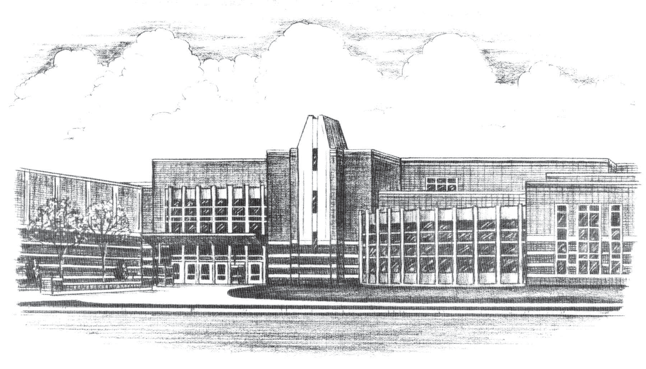

AUGUST |  |  |  |  |  | 2018
SUNDAY | MONDAY | TUESDAY | WEDNESDAY | THURSDAY | FRIDAY | SATURDAY
 |  |  | 1 | 2 | 3 | 4
 |  |  | Parking Permit On-line Applications available
5 | 6 | 7 | 8 | 9 | 10 | 11
12 | 13 | 14 | 15 | 16 | 17 | 18
• Opening Day:
- Cross Country - Boys’ & Girls’
- Football
- Soccer - Boys’ & Girls’
- Swimming & Diving - Girls’
- Tennis - Girls’
- Volleyball
19 | 20 | 21 | 22 | 23 | 24 | 25
26 | 27 | 28 | 29 | 30 | 31
 |  |  | • Parking Permit pick-up,  11:00 a.m. – 1:00 p.m.  • Freshmen and New Student  Orientation, 6:30 p.m. | • Parking Permit pick-up,  11:00 a.m. - 1:00 p.m.
For up-to-the-date calendar information, go to: www.district196.org/evhs then “click” Activity Calendar

SEPTEMBER |  |  |  |  |  | 2018
SUNDAY | MONDAY | TUESDAY | WEDNESDAY | THURSDAY | FRIDAY | SATURDAY
 |  |  |  |  |  | 1
2 | 3 | 4 | 5 | 6 | 7 | 8
 | Labor Day  • No School | • First Day of School  • Pepfest |  |  |  | • ACT Test
9 | 10 | 11 | 12 | 13 | 14 | 15
• School Picture Day
• Parent Open House,
6:30 p.m.
16 | 17 | 18 | 19 | 20 | 21 | 22
• Q4 Spring ‘18 Incomplete
Deadline
23 | 24 | 25 | 26 | 27 | 28 | 29  Homecoming Dance  8:00-11:00 p.m.
 | • Homecoming Week  • Homecoming Ceremony  • Q1 Pass/No Credit  Deadline | • Homecoming Week | • Homecoming Week | • Pepfest  • Homecoming Week | • No School - Teacher  Workshop
For up-to-the-date calendar information, go to: www.district196.org/evhs then “click” Activity Calendar

OCTOBER |  |  |  |  |  | 2018
SUNDAY | MONDAY | TUESDAY | WEDNESDAY | THURSDAY | FRIDAY | SATURDAY
30 | 1 | 2 | 3 | 4 | 5 | 6
 | • Q1 Progress Reports  Communication  • Picture Retake Day |  |  | • Parent/Teacher  Conferences, 5-8:45 p.m. | • No School  • Parent/Teacher  Conferences, 7-10 a.m. | • SAT Test
7 | 8 | 9 | 10 | 11 | 12 | 13
 |  |  | • PSAT Test
14 | 15 | 16 | 17 | 18 | 19 | 20
 |  |  |  | • Teacher Convention  • No School | • Teacher Convention  • No School
21 | 22 | 23 | 24 | 25 | 26 | 27
 |  |  |  |  |  | • ACT Test
28 | 29 | 30 | 31
For up-to-the-date calendar information, go to: www.district196.org/evhs then “click” Activity Calendar

NOVEMBER |  |  |  |  |  | 2018
SUNDAY | MONDAY | TUESDAY | WEDNESDAY | THURSDAY | FRIDAY | SATURDAY
 |  |  |  | 1 | 2 | 3
 |  |  |  |  | • No School-  Staff Development | • SAT Test
4 | 5 | 6 | 7 | 8 | 9 | 10
 |  |  |  |  | • End of Q1
11 | 12 | 13 | 14 | 15 | 16 | 17
 | • First Day of Q2
18 | 19 | 20 | 21 | 22 | 23 | 24
 |  |  |  | Thanksgiving Day  • No School | • No School
25 | 26 | 27 | 28 | 29 | 30
 |  | • Q1 Report Cards distributed  • Q1 Incomplete Deadline |  |  | • No School-  Staff Development
For up-to-the-date calendar information, go to: www.district196.org/evhs then “click” Activity Calendar

DECEMBER |  |  |  |  |  | 2018
SUNDAY | MONDAY | TUESDAY | WEDNESDAY | THURSDAY | FRIDAY | SATURDAY
 |  |  |  |  |  | 1
 |  |  |  |  |  | • SAT Test
2 | 3 | 4 | 5 | 6 | 7 | 8
 |  |  | • Q2 Pass/No Credit  Deadline |  |  | • ACT Test
9 | 10 | 11 | 12 | 13 | 14 | 15
• Q2 Progress Reports
Communication
16 | 17 | 18 | 19 | 20 | 21 | 22
23 | 24 | 25 | 26 | 27 | 28 | 29
 | • No School - Winter Break | • No School - Winter Break | • No School - Winter Break | • No School - Winter Break | • No School - Winter Break
30 | 31
 | • No School - Winter Break
For up-to-the-date calendar information, go to: www.district196.org/evhs then “click” Activity Calendar

JANUARY |  |  |  |  |  | 2019
SUNDAY | MONDAY | TUESDAY | WEDNESDAY | THURSDAY | FRIDAY | SATURDAY
 |  | 1 | 2 | 3 | 4 | 5
 |  | New Year’s Day  • No School – Winter Break | • Parking Permit On-Line Applications available.  • 8th Grade Parent Orientation  6:30 p.m.
6 | 7 | 8 | 9 | 10 | 11 | 12
 |  | Middles School Visits | Middles School Visits |  | • No School-  Teacher Workshop
13 | 14 | 15 | 16 | 17 | 18 | 19
• No School-
Staff Development
20 | 21 | 22 | 23 | 24 | 25 | 26
 | Martin Luther King Day  • No School |  | .  • Parking Permit pick-up  11:00 a.m.-12:30 p.m. | • Parking Permit pick-up  11:00 a.m.-12:30 p.m. | • End of Q2
27 | 28 | 29 | 30 | 31
 | • First Day of Q3
For up-to-the-date calendar information, go to: www.district196.org/evhs then “click” Activity Calendar

FEBRUARY |  |  |  |  |  | 2019
SUNDAY | MONDAY | TUESDAY | WEDNESDAY | THURSDAY | FRIDAY | SATURDAY
 |  |  |  |  | 1 | 2
3 | 4 | 5 | 6 | 7 | 8 | 9
 |  | Registration Homeroom #1 |  |  | • No School-  Staff Development | • ACT Test
10 | 11 | 12 | 13 | 14 | 15 | 16
 | • Q2 Incomplete Deadline |  | Registration Homeroom #2  Quarter 2 Report Cards distributed
17 | 18 | 19 | 20 | 21 | 22 | 23
 | President’s Day  • No School | • Q3 Pass/No Credit Deadline
24 | 25 | 26 | 27 | 28
 | • Q3 Progress Reports  Communication |  | Registration Homeroom #3
For up-to-the-date calendar information, go to: www.district196.org/evhs then “click” Activity Calendar

MARCH |  |  |  |  |  | 2019
SUNDAY | MONDAY | TUESDAY | WEDNESDAY | THURSDAY | FRIDAY | SATURDAY
 |  |  |  |  | 1 | 2
3 | 4 | 5 | 6 | 7 | 8 | 9
 |  |  |  | • Parent/Teacher  Conferences, 5-8:45 p.m. | • No School-  Teacher Workshop | • SAT Test
10 | 11 | 12 | 13 | 14 | 15 | 16
17 | 18 | 19 | 20 | 21 | 22 | 23
24 | 25 | 26 | 27 | 28 | 29 | 30
 | • No School - Spring Break | • No School - Spring Break | • No School - Spring Break | • No School - Spring Break | • No School - Spring Break
31
For up-to-the-date calendar information, go to: www.district196.org/evhs then “click” Activity Calendar

APRIL |  |  |  |  |  | 2019
SUNDAY | MONDAY | TUESDAY | WEDNESDAY | THURSDAY | FRIDAY | SATURDAY
 | 1 | 2 | 3 | 4 | 5 | 6
 |  | • ACT Test Plus Writing  – All 11th Graders |  |  | • End of Q3
7 | 8 | 9 | 10 | 11 | 12 | 13
 | • First Day of Q4  • Homeroom |  |  |  |  | • ACT Test
14 | 15 | 16 | 17 | 18 | 19 | 20
 |  |  |  | • Q3 Report Cards sent home  with students | • No School-  Teacher Workshop
21 | 22 | 23 | 24 | 25 | 26 | 27
 | • Q3 Incomplete Deadline
28 | 29 | 30
 | • Q4 Pass/No Credit Deadline
For up-to-the-date calendar information, go to: www.district196.org/evhs then “click” Activity Calendar

MAY |  |  |  |  |  | 2019
SUNDAY | MONDAY | TUESDAY | WEDNESDAY | THURSDAY | FRIDAY | SATURDAY
 |  |  | 1 | 2 | 3 | 4
 |  |  |  |  |  | • SAT Test
5 | 6 | 7 | 8 | 9 | 10 | 11
 | • Q4 Progress Reports  Communication | • Advanced Placement  Testing  PM – Physics 1 | • Advanced Placement  Testing  AM – English Lit and Comp  PM – European History | • Advanced Placement  Testing  AM – Chemistry  PM – Psychology | • Advanced Placement  Testing  AM – US History  PM – Comp Sci Principles  Studio Art Portfolio Due
12 | 13 | 14 | 15 | 16 | 17 | 18
 | • Advanced Placement  Testing  AM – Biology  PM – Physics C – Mech  PM – Physics C – Elec/Mag | • Advanced Placement  Testing  AM – Calculus AB  AM - Calculus BC | • Advanced Placement  Testing  AM – English Lang/Comp  PM - Macroeconomics | • Advanced Placement  Testing  PM - Statistics | • Advanced Placement  Testing  AM – Microeconomics  PM – Comp Science A
19 | 20 | 21 | 22 | 23 | 24 | 25
26 | 27 | 28 | 29 | 30 | 31
 | Memorial Day  • No School |  |  |  | • Graduation Rehearsal
For up-to-the-date calendar information, go to: www.district196.org/evhs then “click” Activity Calendar

JUNE |  |  |  |  |  |  |  |  |  |  | 2019
SUNDAY | MONDAY |  | TUESDAY |  | WEDNESDAY |  | THURSDAY |  | FRIDAY |  | SATURDAY
 |  |  |  |  |  |  |  |  |  |  | 1
• Graduation
• SAT Test
2 | 3 |  | 4 |  | 5 |  | 6 |  | 7 |  | 8
 |  |  |  |  |  |  |  |  | • End of Q4  • Last day of school |  | • Teacher Workshop
9 | 10 |  | 11 |  | 12 |  | 13 |  | 14 |  | 15
 |  |  |  |  |  |  |  |  |  |  | • ACT Test
16 | 17 |  | 18 |  | 19 |  | 20 |  | 21 |  | 22
 |  |  |  |  |  |  |  |  | • Q4 Report Cards posted
23 | 24 |  | 25 |  | 26 |  | 27 |  | 28 |  | 29
30
JULY |  |  |  |  |  |  |  |  |  |  |  | 2019
SUNDAY |  | MONDAY |  | TUESDAY |  | WEDNESDAY |  | THURSDAY |  | FRIDAY |  | SATURDAY
 |  | 1 |  | 2 |  | 3 |  | 4 |  | 5 |  | 6
 |  |  |  |  |  |  |  | Independence Day
7 |  | 8 |  | 9 |  | 10 |  | 11 |  | 12 |  | 13
 |  |  |  |  |  |  |  |  |  |  |  | • ACT Test
14 |  | 15 |  | 16 |  | 17 |  | 18 |  | 19 |  | 20
21 |  | 22 |  | 23 |  | 24 |  | 25 |  | 26 |  | 27
28 |  | 29 |  | 30 |  | 31
For up-to-the-date calendar information, go to: www.district196.org/evhs then “click” Activity Calendar

